***Electronic circuits***

***IR Sensor Experiment***

***22/12/2023***

|  |  |
| --- | --- |
| ***Names*** | ***ID*** |
| ***عبدالرحمن محمد حسن*** | ***23240087*** |
| ***عبدالرحمن علي موسى*** | ***23240086*** |
| ***عمر عادل محمد*** | ***23240104*** |
| ***عمر أحمد كمال*** | ***23240100*** |

***Supervised by:***

***Dr. Fathi Zaki***

***Dr. Roaa Mubarak***

In this project we will use the infrared radiation to turn on a LED using LM358 comparator

# Idea:

* The energy from infrared radiation is absorbed by P-N junction of IR photodiode and converted to electrical energy which is very less in magnitude.
* We can consider this P-N junction as a tiny cell its output current is directly proportional to the amount of IR radiation falling on it.
* So, we use this current to trigger a led …...HOW?

By translating the current flowing from the sensor to a voltage at a constant resistance.

* And we can control a led basing on the magnitude of this voltage (using ohm law)

More IR Light 🡺 more current 🡺 more voltage across R

# Circuit:

* We use IR receiver and connect the negative terminal to the positive trail like we connect batteries in series and the positive terminal to a negative trail using 10 kΩ resistor.
* Every object in the surroundings emit IR radiation and isn’t consistent so we need an external IR source (TX) to provide us some IR which reflects and hits the RX whenever any object is Infront of them.
* We connect the negative terminal of the IR transmitter to the negative trail using 220 Ω and the positive terminal to the positive trail.

* So, in this setup the voltage at the 10 kΩ is inversely proportional to the distance as shown in figures:

* So as the obstacle comes nearer to the sensor the amount of IR light increases which causes more current to flow through the 10k resistor and more the current more is the voltage across the resistor.
* We need to turn on a LED whenever the obstacle come below a specific level so whenever the voltage is more than a reference voltage the LED turns on.
* So, we use LM358 IC (comparator) to achieve that which is datasheet is showing below:

* In this comparator if the voltage at the non-inverting input (pin3) is more than the voltage at the inverting input (pin2) the output turns on.
* So, we use the comparator to turns on a LED (output) whenever the voltage at IR photodiode (non-inverting input) is more than the reference voltage (inverting input)

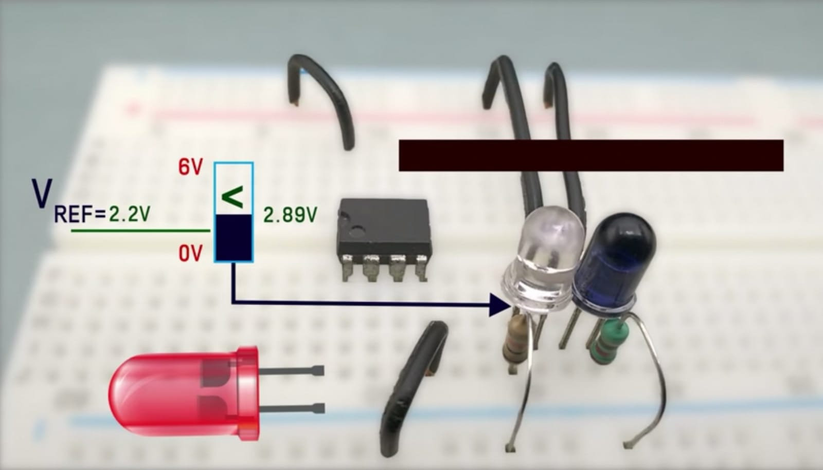Assuming the reference voltage =2.2 volt

The LED turns on when VREF › 2.2v

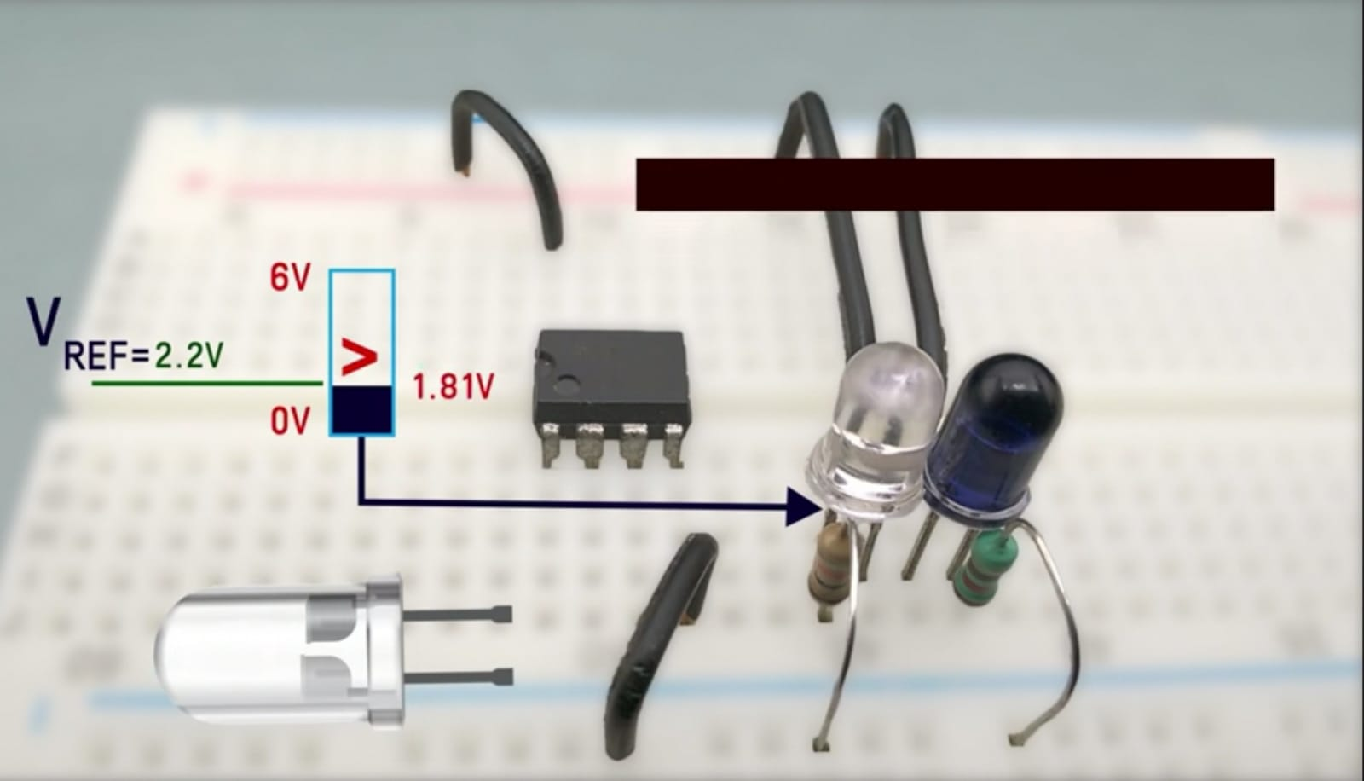

The LED turns off when VREF ‹ 2.2v

* How do we provide a REF voltage that is adjustable?

By using a potentiometer, we can control the Ref Voltage connected at inverting input.

* so, whenever any obstacle gets close that the volt at IR is more than the REF voltage (non-inv › inv) the LED turns on and by using potentiometer in the inverting input we can control the distance that can make the LED turns on.
* We can also connect a buzzer to the output so when any obstacle gets close the LED turns on and we can hear a sound from the buzzer.